SERMON NOTES

RESCUE BAPTIST CHURCH
5201 Deer Valley Rd,
PO Box 232, Rescue, CA 95672
Phone (530) 677-1710

John Reeves, Pastor

Email - rescuebaptist232@gmail.com
Website - www.rescuebaptistchurch.com
sermonaudio.com/rbc232
freegraceradio.com

*We Zoom Friday Night Bible Study & Sunday Morning Services send your
e-mail address to rescuebaptist232@gmail.com to be added to our list

SUNDAY APRIL 9, 2023

COLOSSIANS 2:10-12

And ye are complete in him, which is the head of all principality and power: In whom also ye are circumcised with the circumcision made without hands, in putting off the body of the sins of the flesh by the circumcision of Christ: Buried with him in baptism, wherein also ye are risen with him through the faith of the operation of God, who hath raised him from the dead.
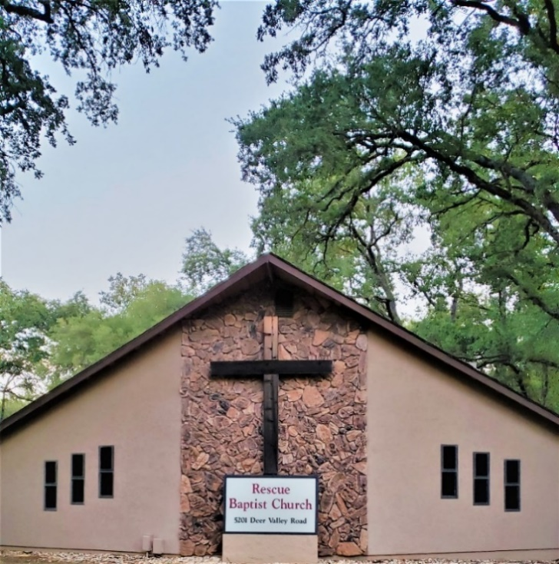

WELCOME TO RESCUE BAPTIST CHURCH

“Sinners are welcome at this church. We are a local body of the Lord Jesus Christ. As you spend time with us, you’ll soon discover we’re an imperfect church, with an imperfect pastor, yet by God’s undeserved grace, we preach, believe, and know the perfect gospel of our never-failing Lord Jesus Christ. We call His name Jesus for He shall, (not might, not maybe) but shall save His people from their sins, and every sinner that trusts in Christ is complete in Him, saved to the uttermost” Hebrews 7:25 (copied)

SCHEDULED MEETINGS
Sunday Morning Bible Study 10:00 AM
Sunday Morning Worship 11:00 AM
Friday Night Bible Study 7:00 PM

OPENING CHRIST AROSE PAGE 216

SCRIPTURE READING GENESIS 37:31-36 / 39:1-7

WORSHIP HYMN HE LIVES PAGE 220
MESSAGE

CLOSING HYMN JESUS SAVES PAGE 306

“Surely he hath borne our griefs, and carried our sorrows: yet we did esteem him stricken, smitten of God, and afflicted. But he was wounded for our transgressions, he was bruised for our iniquities: the chastisement of our peace was upon him; and with his stripes we are healed. All we like sheep have gone astray; we have turned every one to his own way; and the LORD hath laid on him the iniquity of us all.” Isaiah 53:4-6

THINGS TO PONDER

God’s Design - A New Earth - Populated The Grand Design of the Heavenly Father in creation, providence, and salvation is to have a new heaven and a new earth, wherein dwelleth righteousness, populated by a holy people out of all nations, perfectly conformed to the likeness of His Son. This work He gave to our Lord Jesus in the eternal council and covenant to accomplish, to perfect, and to deliver to Him at the end. And “He shall not fail nor be discouraged ’til it is done.” -Pastor Henry Mahan

ANNOUNCEMENTS
- Next Sunday we will immediately come to the Lord’s Table following our morning message.

"The Prayer Of Faith..."
James 5:15

James assures us that the prayer of faith, the prayer that is born of and caused by faith in Christ, shall save the sick. Of course, the word "save" means "deliver." The prayer of faith shall, most assuredly, deliver the sick from his sickness. What is "the prayer of faith"? The next verse tell us: "The effectual, fervent prayer of a righteous mean availeth much."

THE PRAYER OF FAITH IS "EFFECTUAL". The word used by James means "in wrought". It is a prayer wrought in or produced in the heart of a believer by the Spirit of God. It is a prayer that is found in the heart (II Sam. 7:27), produced by the work of God and based upon the Word of God. Without question, the prayer of faith willingly submits to the will of God. But there is more to it than that. The prayer of faith discerns what the will of God is by the illumination of the Holy Spirit in his heart (Rom. 8:27). And the prayer of faith is according to the will of God (I John 5:14).

THE PRAYER OF FAITH IS "FERVENT". Faith is im-portunate. It will not give up its plea until it obtains the mercy it seeks (Luke 11:8-10).Like the Syrophenician woman, faith cannot be turned away (Matt. 15:21-28).

THE PRAYER OF FAITH IS THE PRAYER OF "A RIGHTEOUS MAN", one who has been made righteous by the imputation of Christ's righteousness to him and by the cleansing of his blood. It is the prayer of one who draws near to, calls upon, and is accepted of God in the name of the Lord Jesus Christ (John 14:15; Heb. 7:25).

AND THE PRAYER OF FAITH "AVAILETH MUCH". The prayer of the righteous is God's delight; therefore "he heareth the prayer of the righteous" (Prov. 15:8,29). "And this is the confidence that we have in him, that if we ask anything according to his will, he heareth us: and if we know that he hear us, whatsoever we ask, we know that we have the petitions that we desired of him" (I John 5:14-15).We have what we desire, because what we desire is what our heavenly Father desires - his will and his glory. We gladly subject all our desires to these two things. The prayer of faith is free of selfish desire and personal want(James 4:3). The prayer of faith wants what God has purposed. Therefore, it is always effectual. If my will is subject to and in harmony with my Father's will, I may, and most assuredly shall, have what I will. ~Don Fortner

